Project Methodology

Waterfall Model

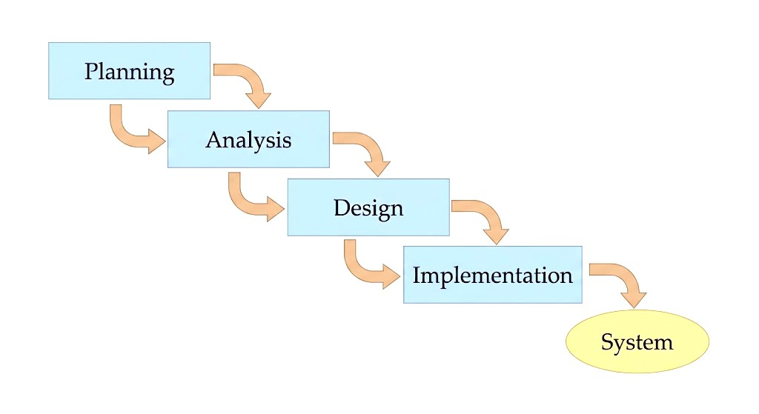
Time Estimation
 | Planning | Analysis | Design | Implementation
Standard percentages | 15% | 20% | 35% | 30%
Estimated time based on planning time | 1.5months | 2months | 3.5months | 3months

Tasks Identification
System Request | Name of Task
1/11/2026 | Start Date
7/11/2026 | End Date
Haidy Emad | Person assigned to task
High | Priority
Microsoft word | Resources Needed
1 Week | Estimated Time
4 days | Actual Time

Feasibility Study | Name of Task
8/11/2026 | Start Date
21/11/2026 | End Date
Rehab Ayman | Person assigned to task
High | Priority
Microsoft word | Resources Needed
2 Weeks | Estimated Time
10 days | Actual Time

Pert Chart, Gant Chart | Name of Task
22/11/2026 | Start Date
5/12/2026 | End Date
Shahd Elshiekh | Person assigned to task
High | Priority
Ms project | Resources Needed
2 Weeks | Estimated Time
10days | Actual Time

Interview | Name of Task
6/12/2026 | Start Date
12/12/2026 | End Date
Rehab Ayman | Person assigned to task
Medium | Priority
Microsoft word | Resources Needed
1week | Estimated Time
5days | Actual Time

Questionnaire | Name of Task
13/12/2026 | Start Date
19/12/2026 | End Date
Haidy Emad | Person assigned to task
medium | Priority
Form drive | Resources Needed
1week | Estimated Time
4days | Actual Time

Data Flow Diagram | Name of Task
20/12/2026 | Start Date
9/1/2027 | End Date
Shahd Elshiekh | Person assigned to task
High | Priority
Internet | Resources Needed
3weeks | Estimated Time
14days | Actual Time

Data Store | Name of Task
9/1/2027 | Start Date
16/1/2027 | End Date
Rehab Ayman | Person assigned to task
High | Priority
Microsoft word | Resources Needed
1 Week | Estimated Time
5 days | Actual Time

process specification | Name of Task
17/1/2027 | Start Date
1/2/2027 | End Date
Haidy Emad | Person assigned to task
High | Priority
Microsoft word | Resources Needed
2week | Estimated Time
10days | Actual Time

Entity Relationship | Name of Task
2/2/2027 | Start Date
9/2/2027 | End Date
Shahd Elshiekh | Person assigned to task
High | Priority
StarUML | Resources Needed
1weeks | Estimated Time
7days | Actual Time

Normalization | Name of Task
10/2/2027 | Start Date
24/2/2027 | End Date
Rehab Ayman | Person assigned to task
High | Priority
StarUML | Resources Needed
2week | Estimated Time
10days | Actual Time

design | Name of Task
25/2/2027 | Start Date
25/5/2027 | End Date
Haidy Emad | Person assigned to task
High | Priority
Visual studio code | Resources Needed
3months | Estimated Time
2.5 month | Actual Time

Implementation | Name of Task
26/5/2027 | Start Date
29/7/2027 | End Date
Shahd Elshiekh | Person assigned to task
High | Priority
Visual studio code | Resources Needed
2month | Estimated Time
2month | Actual Time

 |  |  | Estimated |  |  | Actual
Task ID | Task Name | Assigned to | Duration (Days) | Start Date | Finish Date | Start Date | Finish Date | Duration |  | Dependency | Status
A | System Request | Haidy Emad | 7 | 2026-11-01 | 2026-11-07 | 2026-11-01 | 2026-11-04 | 4 |  | - |  | Closed
B | Feasibility Study | Rehab Ayman | 14 | 2026-11-08 | 2026-11-21 | 2026-11-08 | 2026-11-17 | 10 |  | A |  | Closed
C | Pert Chart, Gantt Chart | Shahd Elshiekh | 14 | 2026-11-22 | 2026-12-05 | 2026-11-22 | 2026-11-29 | 8 |  | B |  | Closed
D | Interview | Rehab Ayman | 10 | 2026-12-06 | 2026-12-12 | 2026-12-06 | 2026-12-10 | 5 |  | C |  | Closed
E | Questionnaire | Haidy Emad | 7 | 2026-12-13 | 2026-12-19 | 2026-12-13 | 2026-12-16 | 4 |  | D |  | Closed
F | Data Flow Diagram | Shahd Elshiekh | 21 | 2026-12-20 | 2027-01-09 | 2026-12-20 | 2026-12-1 | 14 |  | E |  | Closed
G | Data Store | Rehab Ayman | 7 | 2027-01-09 | 2027-01-16 | 2027-01-09 | 2027-01-14 | 5 |  | F |  | Closed
H | Process Specification | Haidy Emad | 14 | 2027-01-17 | 2027-02-1 | 2027-01-17 | 2027-01-27 | 10 |  | G |  | Closed
I | Entity Relationship | Shahd Elshiekh | 7 | 2027-02-2 | 2027-02-09 | 2027-02-2 | 2027-02-09 | 7 |  | H |  | Closed
J | Normalization | Rehab Ayman | 14 | 2027-02-10 | 2027-02-24 | 2027-02-10 | 2027-02-20 | 10 |  | I |  | Closed
K | Design | Haidy Emad | 90 | 2027-02-25 | 2027-05-25 | 2027-02-25 | 2027-05-10 | 65 |  | J |  | Closed
L | Implementation | Shahd Elshiekh | 60 | 2027-05-26 | 2027-07-29 | 2027-05-26 | 2027-07-29 | 60 |  | K |  | Closed

Pert Chart
Activity | Description | Predecessors | Duration in days
A | System Request | - | 4
B | Feasibility Study | A | 10
C | Pert Chart, Gantt Chart | B | 8
D | Interview | C | 5
E | Questionnaire | D | 4
F | Data Flow Diagram | E | 14
G | Data Store | F | 5
H | Process Specification | G | 10
I | Entity Relationship | H | 7
J | Normalization | I | 10
K | Design | J | 65
L | Implementation | K | 60

